Airside Vehicle Dispensation Request Form
Please fully complete all questions and return to the Aerodrome Ground Handling and Apron Team
(aerodromegha-team@gatwickairport.com)
1 | Your Full Name
2 | Company Name
3 | Vehicle Registration Number
4 | What is the vehicle date of manufacture?
5 | Vehicle Make, Model and Colour e.g. White Toyota Yaris
6 | What is the fuel type?
7 | How long is the vehicle going to remain airside?
8 | Do you have a vehicle replacement plan?
9 | How many vehicles does your company have based at Gatwick?
10 | What is the purpose of the vehicle airside?
11 | Is the vehicle a private or company vehicle?
12 | Has the vehicle been modified or is it a specialist vehicle?  – If Yes, please provide details
13 | Has the vehicle been upgraded with regards to emissions?  – If Yes, please provide details
14 | Where will the vehicle be parked when airside?
15 | Where will the vehicle be parked when not in use airside?
16 | Is the vehicle currently operating airside at Gatwick?  - If Yes, answer question 17. | Yes / No
17 | Please provide a clear copy of the current AVP as shown in the example:  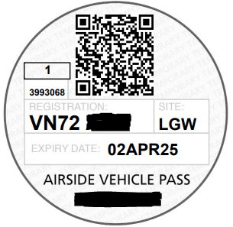

Additional Information
Confirm Vehicle Registration Number:

For Aerodrome GHA Team Office use only
Approved by GAL
Authorised signatory
Date

